

# Smart Agriculture System Using IoT

**Project Presentation**

***Submitted as a training project for***

**The Smart Bridge May 2020- June 2020 *By***

**Gaurav Baghel**

***Under the Guidance of***

**Mr. Durga Prasad Bethi**

[**durgaprasad@thesmartbridge.com**](mailto:durgaprasad@thesmartbridge.com)



# Overview:

Despite the perception people may have regarding the agricultural process, the reality is that

today's agriculture industry is data-centred , precise, and smarter than ever. The rapid emergence of the Internet-of-Things (IoT) based technologies redesigned almost every industry including smart agriculture which moved the industry from statistical to quantitative approaches. Such revolutionary changes are shaking the existing agriculture methods and creating new opportunities along a range of challenges. This article highlights the potential of wireless sensors and IoT in agriculture, as well as the challenges expected to be faced when integrating this technology with the traditional farming practices. IoT devices and communication techniques associated with wireless sensors encountered in agriculture applications are analysed in detail. What sensors are available for specific agriculture application, like soil preparation, crop status, irrigation, insect and pest detection are listed. How this technology helping the growers throughout the crop stages, from sowing until harvesting, packing and transportation is explained. Furthermore, the use of unmanned aerial vehicles for crop surveillance and other favourable applications such as optimizing crop yield is considered in this article. State-of-the-art IoT-based architectures and platforms used in agriculture are also highlighted wherever suitable. Finally, based on this thorough review, we identify current and

future trends of IoT in agriculture and highlight potential research challenges



## Purpose:

**The main aim of this project is to turn on and off water pump from anywhere using mobile phone.**

* Smart Agriculture System based on IoT can monitor soil moisture and climatic conditions to grow and yield a good crop.
* The farmer can also get the real time weather forecasting data by using external

platforms like Open Weather API.

* Farmer is provided a mobile app using which he can monitor the temperature , humidity and soil moisture parameters along with weather forecasting details.
* Based on all the parameters he can water his crop by controlling the motors using the mobile application.
* Even if the farmer is not present near his crop he can water his crop by controlling

the motors using the mobile application from anywhere.

* This can be a ground-breaking invention for people still using traditional agricultural techniques.



# Literature survey:

* 1. **Existing Problems**
  + Monitoring of climate conditions is a difficult task for most of the farmers.
  + Crop management without specific data and conditions of the field affects the crop health.
  + Inability to water the crops in right amount and without man power.
  + Loss of resources and quality due to excessive grazing of animals.



# Proposed Solutions:

* **Monitoring of climate conditions:** Probably the most popular smart agriculture gadgets are weather stations, combining various smart farming sensors. Located across the field, they collect various data from the environment and send it to the cloud. The provided measurements can be used to map the climate conditions, choose the appropriate crops, and take the required measures to improve their capacity.
* **Crop management :** One more type of IoT product in agriculture and another element of precision farming are crop management devices. Just like weather stations, they should be placed in the field to collect data specific to crop farming; from temperature and precipitation to leaf water potential and overall crop health.
* **Smart Irrigation system:** Even if the farmer is not present near his crop he can water his

crop by controlling the motors using the mobile application from anywhere.

* **Cattle monitoring and management:** Just like crop monitoring, there are IoT agriculture sensors that can be attached to the animals on a farm to monitor their health and log performance. This works similarly to IoT devices for petcare.
  1. **Block Diagram:**

# Theoretical Analysis:



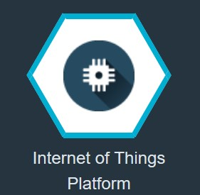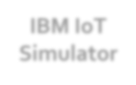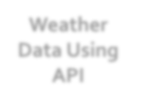

**Web App**

**IBM WATSON**

**Cloud Platform**

**IBM IoT**

**Simulator**

**Node-Red**

**Weather Data Using API**

**IoT IBM**

**Platform**

**Motor ON**

**/OFF**



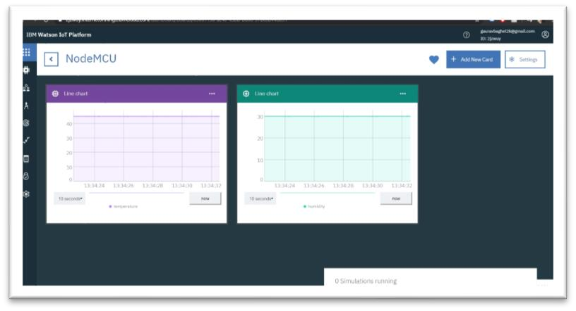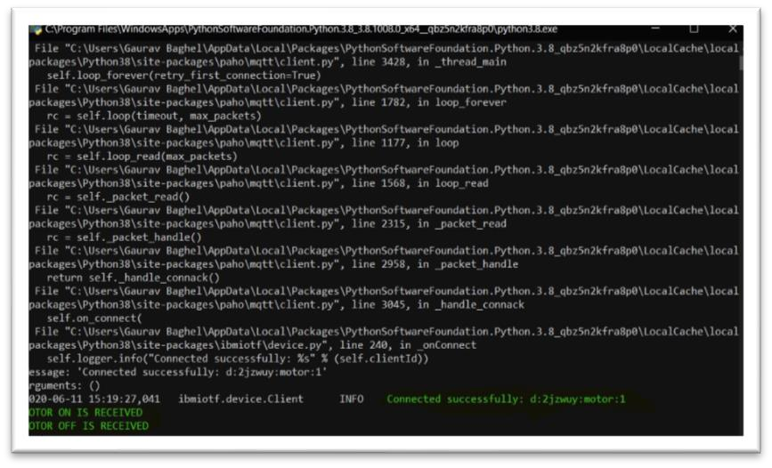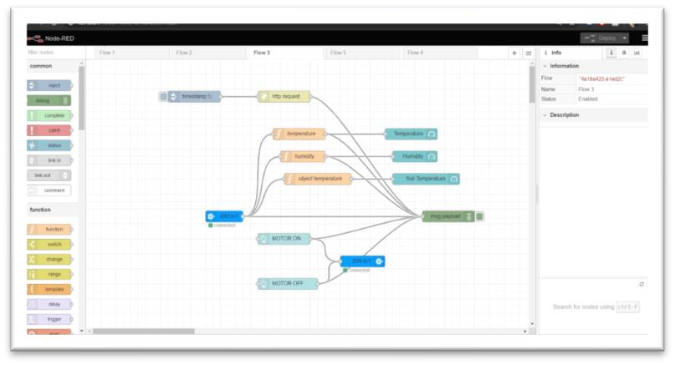

### Software Designing:

* IBM cloud
* Python
* Open weather API
* Nodes

**4.**

**Experimental Investigations:**

* Support for virtually any IoT device: The key challenge that we faced in developing the SmartFarmNet platform was managing the plethora of Internet of Things devices, ranging from wireless sensor networks to mobile smart phones to cameras, etc
* Provide rapid analysis of data in real-time: One fundamental challenge that underpinned most IoT platforms was in their ability to perform fast analysis of data over a large number of sensor data streams
* visualisation and analysis of data: The design objective of SmartFarmNet was to empower its users by providing standard tools combined with a flexible and powerful API. By employing a do-it-yourself approach, SmartFarmNet has reached a wider set of users and enabled them to collect crop performance data with any sensor(s)



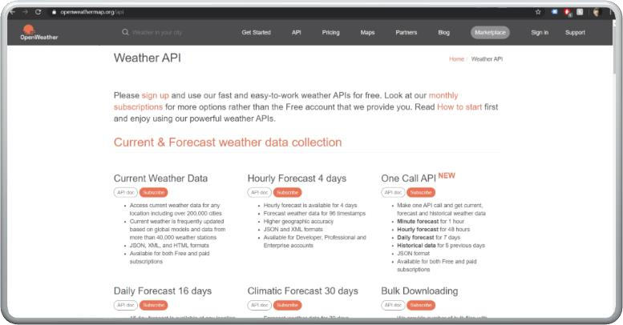

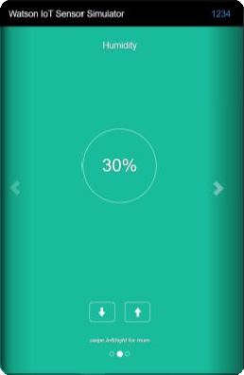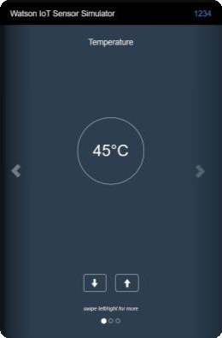



**5.**

**Flowchart:**

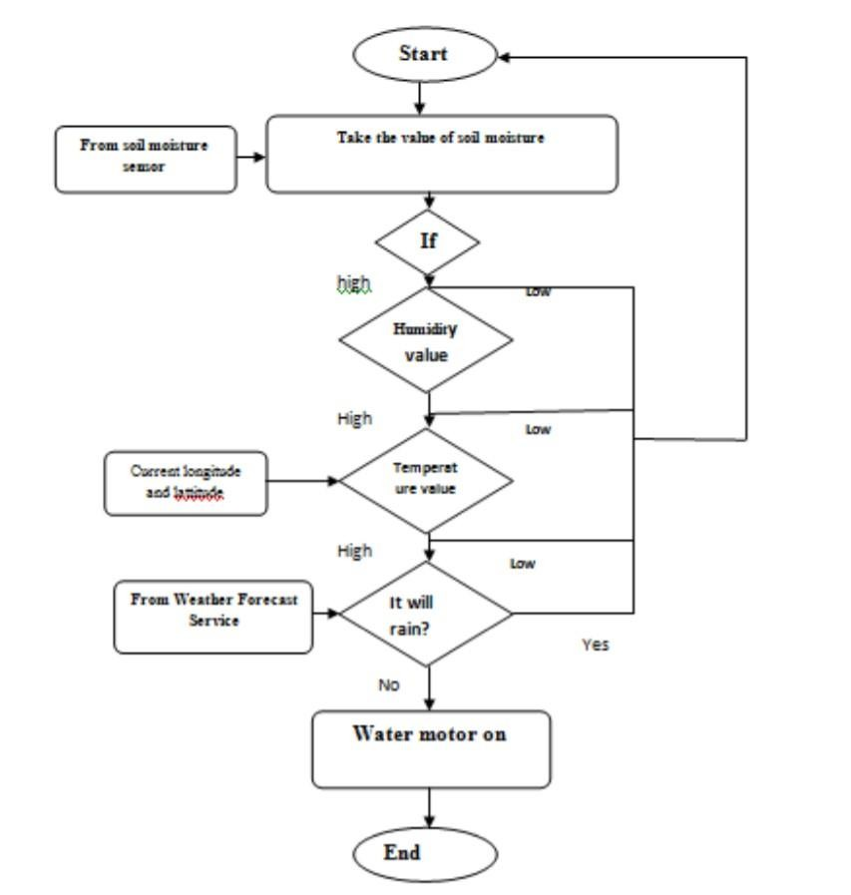



1. **Result:**

* IoT based Smart Farming improves the entire Agriculture system by monitoring the field in real-time. With the help of sensors and interconnectivity, the Internet of Things in Agriculture has not only saved the time of the farmers but has also reduced the extravagant use of resources such as Water and Electricity.

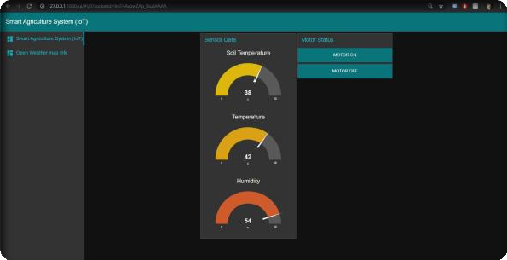

* An mobile application that can monitor the temperature , humidity and soil moisture parameters along with weather forecasting details. Also, based on these parameters user can water his crops by controlling the motors.

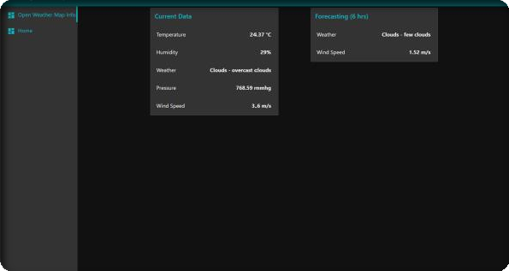

* IoT enabled agriculture has helped implement modern technological solutions to time tested knowledge. With seamless end to end intelligent operations and improved business process execution, produce gets processed faster and reaches supermarkets in fastest time possible.



# Advantages:

Following are the benefits or **advantages of Smart Agriculture**:

* It allows farmers to maximize yields using minimum resources such as water, fertilizers, seeds etc.
* Solar powered and mobile operated pumps save cost of electricity.
* Smart agriculture use drones and robots which helps in many ways. These improves data collection process and helps in wireless monitoring and control.
* It is cost effective method.
* It delivers high quality crop production.



# Disadvantages:

Following are the drawbacks or **disadvantages of Smart Agriculture**:

* The smart agriculture needs availability of internet continuously. Rural part of most of the developing countries do not fulfil this requirement. Moreover internet connection is slower.
* The smart farming based equipment requires farmers to understand and learn the use of technology. This is major challenge in adopting smart agriculture farming at large scale across the countries.



# Applications:

IoT based remote sensing utilizes sensors placed along the farms like weather stations for gathering data which is transmitted to analytical tool for analysis. Sensors are devices sensitive to anomalies. Farmers can monitor the crops from analytical dashboard and take action based on insights.

* **Crop Monitoring**

Sensors placed along the farms monitor the crops for changes in light , humidity, temperature, shape and size. Any anomaly is detected by the sensors is analysed and farmer is notified. Thus remote sensing can help prevent the spread of diseases and keep an eye on the growth of crops.

* **Weather conditions**

The data collected by sensors in terms of humidity, temperature, moisture precipitation and dew

detection helps in determining the weather pattern in farms so that cultivation is done for suitable crops.

* **Soil quality**

The analysis of quality of soil helps in determining the nutrient value and drier areas of farms, soil drainage capacity or acidity, which allows to adjust the amount of water needed for irrigation and the opt most beneficial type of cultivation.



# Conclusion:

* This report discusses IoT based system in agriculture and its system design implementation. The importance of IoT and data analysis has been presented for effective and efficient farming practices. The WSN nodes and their connection with the internet is designed and presented. The effective use of available systems in control system is also presented. This paper suggests the use of cloud-based services especially for database of the data from different sensors and actuator nodes. On software side, this paper proposes the implementation of time series-based database and as control and visualization software, node-red based application



# Future Scope:

* The IoT system has bright future in agriculture sector as it is perfect match for it. For better ease of integration and maximization of system usage, the government must upgrade their policy. The government should facilitate farmers by developing basic infrastructure of internet, availability of governmental plan and policy regarding agriculture. The main limitation is cost and system knowledge. The government should realize importance of the information that can be generated from IoT system and hence encourage farmers for the same providing cheaper loans and ease of access to IoT devices and services. The farmers should be educated, and vocational training programs should be developed for better use of system.



# Bibliography:

* <https://www.cropin.com/iot-internet-of-things-applications-agriculture/>
* [https://www.biz4intellia.com/blog/5-applications-of-iot-in- agriculture/#:~:text=IoT%20based%20Smart%20Farming%20improves,suc h%20as%20Water%20and%20Electricity.](https://www.biz4intellia.com/blog/5-applications-of-iot-in-agriculture/#%3A%7E%3Atext%3DIoT%20based%20Smart%20Farming%20improves%2Csuch%20as%20Water%20and%20Electricity)
* file:///C:/Users/Gaurav%20Baghel/Downloads/sensors-16-01884-v2.pdf
* [http://www.ijstr.org/final-print/dec2019/Internet-Of-Things-iot-For-Smart- Agriculture-And-Farming-In-Developing-Nations.pdf](http://www.ijstr.org/final-print/dec2019/Internet-Of-Things-iot-For-Smart-Agriculture-And-Farming-In-Developing-Nations.pdf)
* [https://www.researchgate.net/publication/334858202_Internet-of- Things_IoT-Based_Smart_Agriculture_Toward_Making_the_Fields_Talk](https://www.researchgate.net/publication/334858202_Internet-of-Things_IoT-Based_Smart_Agriculture_Toward_Making_the_Fields_Talk)



# Appendix:

### Project title:

Smart Agriculture System Based On IoT

### Period covered:

from 09/05/2020 to 13/06/2020

### Name of the representative of the project ,Title and Organisation:

Gaurav Baghel ,Summer Intern , Smartinternz- Smart Bridge Educational

Services

* **Email Id:** [gauravbaghel2k@gmail.com](mailto:gauravbaghel2k@gmail.com)
* **Project website address:** https://smartinternz.com/



Thank You !